Arbentia - Euro CRM
Dynamics 365 and Power Platform Guidelines

Author: Timothy Dundon
Date: 24/09/2025
Version: 1
Status: Draft
Domain Architect: N/A
Table of Contents
Document Purpose 3
Environment Guidelines 3
Security and Data Access Guidelines 4
Entra ID Configuration 4
Dataverse Auditing 5
Security Role Auditing 5
Environment Security & Data Security 6
Application Lifecycle Management (ALM) Guidelines 6
ALM Strategy 7
ALM constraints 7
Solution Guidelines 7
Managed solutions 8
Unmanaged Solutions 9
Solution Constraints 9
Solution Segregation 9
Layering Strategy 10
Prescribed pattern for Solution Layers: 11
Common Data Model - System Layer 11
First Patry Apps Layer (Dynamics 365 / Power platform accelerators) 11
ISV Solution(s) Layer 11
Enterprise Solution Layer (Core Solutions) 11
Knight Frank App-Specific 12
Regional / Localisation Layers 12
Storage Guidelines 12
Application and Platform monitoring Guidelines 13
Capacity Monitoring 13
Application Performance Monitoring 13
CoE Starter Kit 13
Microsoft Purview 13
Azure Extensions Guidelines 14
Appendix 15
Knight Frank SLA classifications 15
Gold 15
Silver 15
Bronze 15

Document Purpose
This document outlines the guidelines for compliance requirements, delivery standards, and governance principles that vendors must adopt to when implementing solutions based on Microsoft Dynamics 365 Customer Engagement applications and the Power Platform.
Its purpose is to ensure consistency, quality, security, and alignment with organisational architecture and strategic objectives. By defining clear expectations across solution design, development, deployment, and support, this document serves as a foundational reference for vendor engagement, helping to mitigate risks and promote successful project outcomes.

Environment Guidelines
Knight Frank operate an environment strategy with 5 tiers:
Env | Purpose
Development [Volatile] | Used to create and develop solutions as unmanaged collections
Feature [Volatile] | Used to test feature / solution development in a managed environment
Test [Stable] | Provided as a stable UAT environment used to engage stakeholders and obtain Acceptance of features and solutions
Preproduction [Stable] | Provided as a preproduction tier allowing for deployment rehearsal and production performance testing.
Production [Stable] | The Production tier used for organisational operations.
Table 1 – Environments
If a vendor or implementation partner is not following this strategy, details of the environment tiers and purpose’s must be provided accompanied by the rationale as part of a Solution Design Document / Low Level Design.
Additional details, and justification will be required if integrations or dependencies cross an environmental boundary.

Security and Data Access Guidelines

Entra ID Configuration
The following Entra ID structures should be followed when designing the delivery, support and operational security measures to support a dynamics solution.
The goal is to enable Joiner, Mover, Leaver (JML) processes to be efficient by inferring the appropriate Dynamics 365 and Power Platform security roles from the user’s inclusion in Entra ID groups.
- Environmental Groups – used to define which users can access a dynamics environment, typically segmented into per environment groups:
  - Dynamics 365 Access – Euro CRM – Development
  - Dynamics 365 Access – Euro CRM – Feature
  - Dynamics 365 Access – Euro CRM – Test
  - Dynamics 365 Access – Euro CRM – Staging
  - Dynamics 365 Access – Euro CRM – Production

- Role Based Groups – used to define the role and permissions a user will provided upon authentication and authorization when accessing an environment. These groups should be used to map to the predefined security roles provided by the platform.
Entra Group | D365 Security Role
Administration Roles | System Administrator
Super User Roles | System Customizer
Sales Manager Roles | Sales Manager

  - Super User Roles
  - Developer Roles
  - Support Roles
  - Sales User Role
  - Marketing Manager Role
  - Marketing User Role
- Business Unit Groups – used to define the dynamics 365 Business unit a user is bound to and the related security roles provisioned for that business unit.
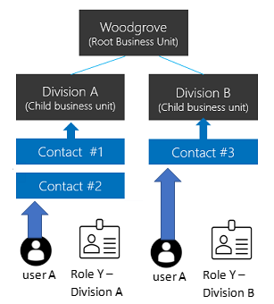
Figure 1 - Business Unit example
- App Registrations and Enterprise Applications – used to manage access to the environments for external apps and services which need to interact with the Dynamics 365 / power platform environment.
- Service Principles – Used to represent applications and automations and provide an identity upon which a non-interactive process can run (CI/CD, Test Automation, Flows).
- Conditional Access Policies – Used to establish and enforce rules about who can access the platforms and under what circumstances a user can access the platforms. Policies should adopt a Zero Trust posture and rely upon the principle of least privilege and risk-based compromise.

Dataverse Auditing
Dataverse is the underlying data storage platform that provides the foundation for Dynamics 365 and Power Platform applications. To ensue Knight Frank can meet internal and external Compliance and Security standards. Dataverse Auditing should be enabled per environment, with the records that will be audited should be specified in a Solution Design Document and agreed with Knight Frank Group GRC (Governance, Risk and Compliance) teams.

Security Role Auditing
To ensure compliance in line with ISO 27001, auditing of the management of security roles should be turned on and configured.

Environment Security & Data Access Security
All aspects of the application security option available for Dynamics 365 and Power platform should be appraised, however particular attention should be paid to:
- Ensuring Same Site cookies are enforced.
- Ensuring Content Security Policies are configured and enforced. If possible, reporting should be enabled.
- Column Level security must be enabled to limit access to PII to only those roles that require it.

Application Lifecycle Management (ALM) Guidelines
Knight Frank enforces ALM guidelines based upon the Microsoft Best Practices, and asks vendors and implementation partners to ensure that the best practice check list is applied

ALM System
The Application Lifecycle Management of the implementation must leverage the Azure DevOps platform, which will be provided by Knight Frank.

ALM constraints
The following Constraints must be adhered to:
- All source code excluding vendor IP, must be kept in Knight Frank provided Azure DevOps projects and Git repositories.
- Where source code is dependent on Vendor IP, the Vendor IP dependencies must be provided as packaged objects which can be independently managed.
- All CI, CD work such as pipelines and test automation must be hosted in Knight Frank owned systems (Azure DevOps / Power Platform)
- All ‘deployment’ behaviours must have gates to ensure that approvals are tracked, and an auditable record is maintained (excluding the development environment).

Solution Guidelines
The architecture of the power platform is based upon a non-destructive layering that allows configuration and customisation through the installation and management of solutions.
The active / runtime configuration of a Power Platform / Dynamics 365 environment is defined not only be the solutions deployed, but the order of deployment and type of solutions.

Managed solutions
A Managed solution can be summarised as a configuration package which has been developed and outside of the environment to which it is being deployed and packaged to prevent changes to the solution definition when deployed.
The goal of a managed solution is to provide:
- Controlled Deployments
Managed Solutions are Read Only in the deployed environment, and prevent modification to the included components (apps, flows, tables, etc).
- Version Control
Managed solutions use semantic versioning, this provides a mechanism to help track changes and modifications to a solution, in addition to providing a mechanism by which a solution can be upgraded or patched.
- Security and Governance
Managed solutions allow elements to be marked as immutable, allowing for the implementation of governance policies, and preventing unauthorised changes being made to these elements.
- IP Protection
Managed solutions also hide / abstract implementation details of custom functionality and are the recommended method of distributing functionality through marketplaces such as AppSource or when implementing an ISV solution.

Unmanaged Solutions
Unmanaged solutions are used during development, they provide a mechanism for teams to iterate, and update the solution without needing to publish, install, upgrade or patch.
The goal of an unmanaged solution is:
- Provide a way to sperate concerns during development (tables, forms)
- Provide a way to allow customisation of the package when deployed in another environment.
- Provide source control snapshots.

Solution Constraints
- Unmanaged solutions are only allowed in the development environment, unless explicit approval has been obtained and recorded as part of the implementation governance.
- Solution publishers must provide the same ‘Publisher Name’ for all solutions maintained by the publisher.
- If not already established a suitable publisher prefix should be defined to ensure ease of identification when auditing objects maintained by the publisher.
- Solutions should never modify ‘core’ MS Owned / System data objects and instead should extend them via custom / virtual tables and relationships / alternate keys.
- Solutions (inc ISV solutions) that impact / change the Microsoft Owned layers, must seek and exemption from the appropriate forum / authority. Allowing for mitigation and remediation strategies to be considered.
- ISV solutions must implement restrictions to ensure that future or custom solutions can not adversely impact the operation of the ISV solution.

Solution Segregation
To facilitate the ease of maintenance and platform coherence, the best practices of solution segregation will be followed.
- Tables used in an application solutions must be in an accompanying solution and follow the Table Segregation pattern of packaging only changed objects. (https://learn.microsoft.com/en-us/power-platform/alm/segmented-solutions-alm?source=recommendations)
- Solution Segregation of the following object types is mandated but considerations / exemptions for existing and ISV solutions will be made:
  - Table Data (Data models)
  - Processes (flows and automations)
  - UI (forms, cards, etc)

Layering Strategy
The Knight Frank solution layering strategy is considerate of the two methodologies available in the power platform / dynamics 365 environments.
- Merged method – These object types, merge across solution layers, meaning changes from multiple solutions are combined.
- Top Wins method - These object types follow a top win’s model, meaning the topmost layer (usually the most recently installed or customized solution) overwrites the component.
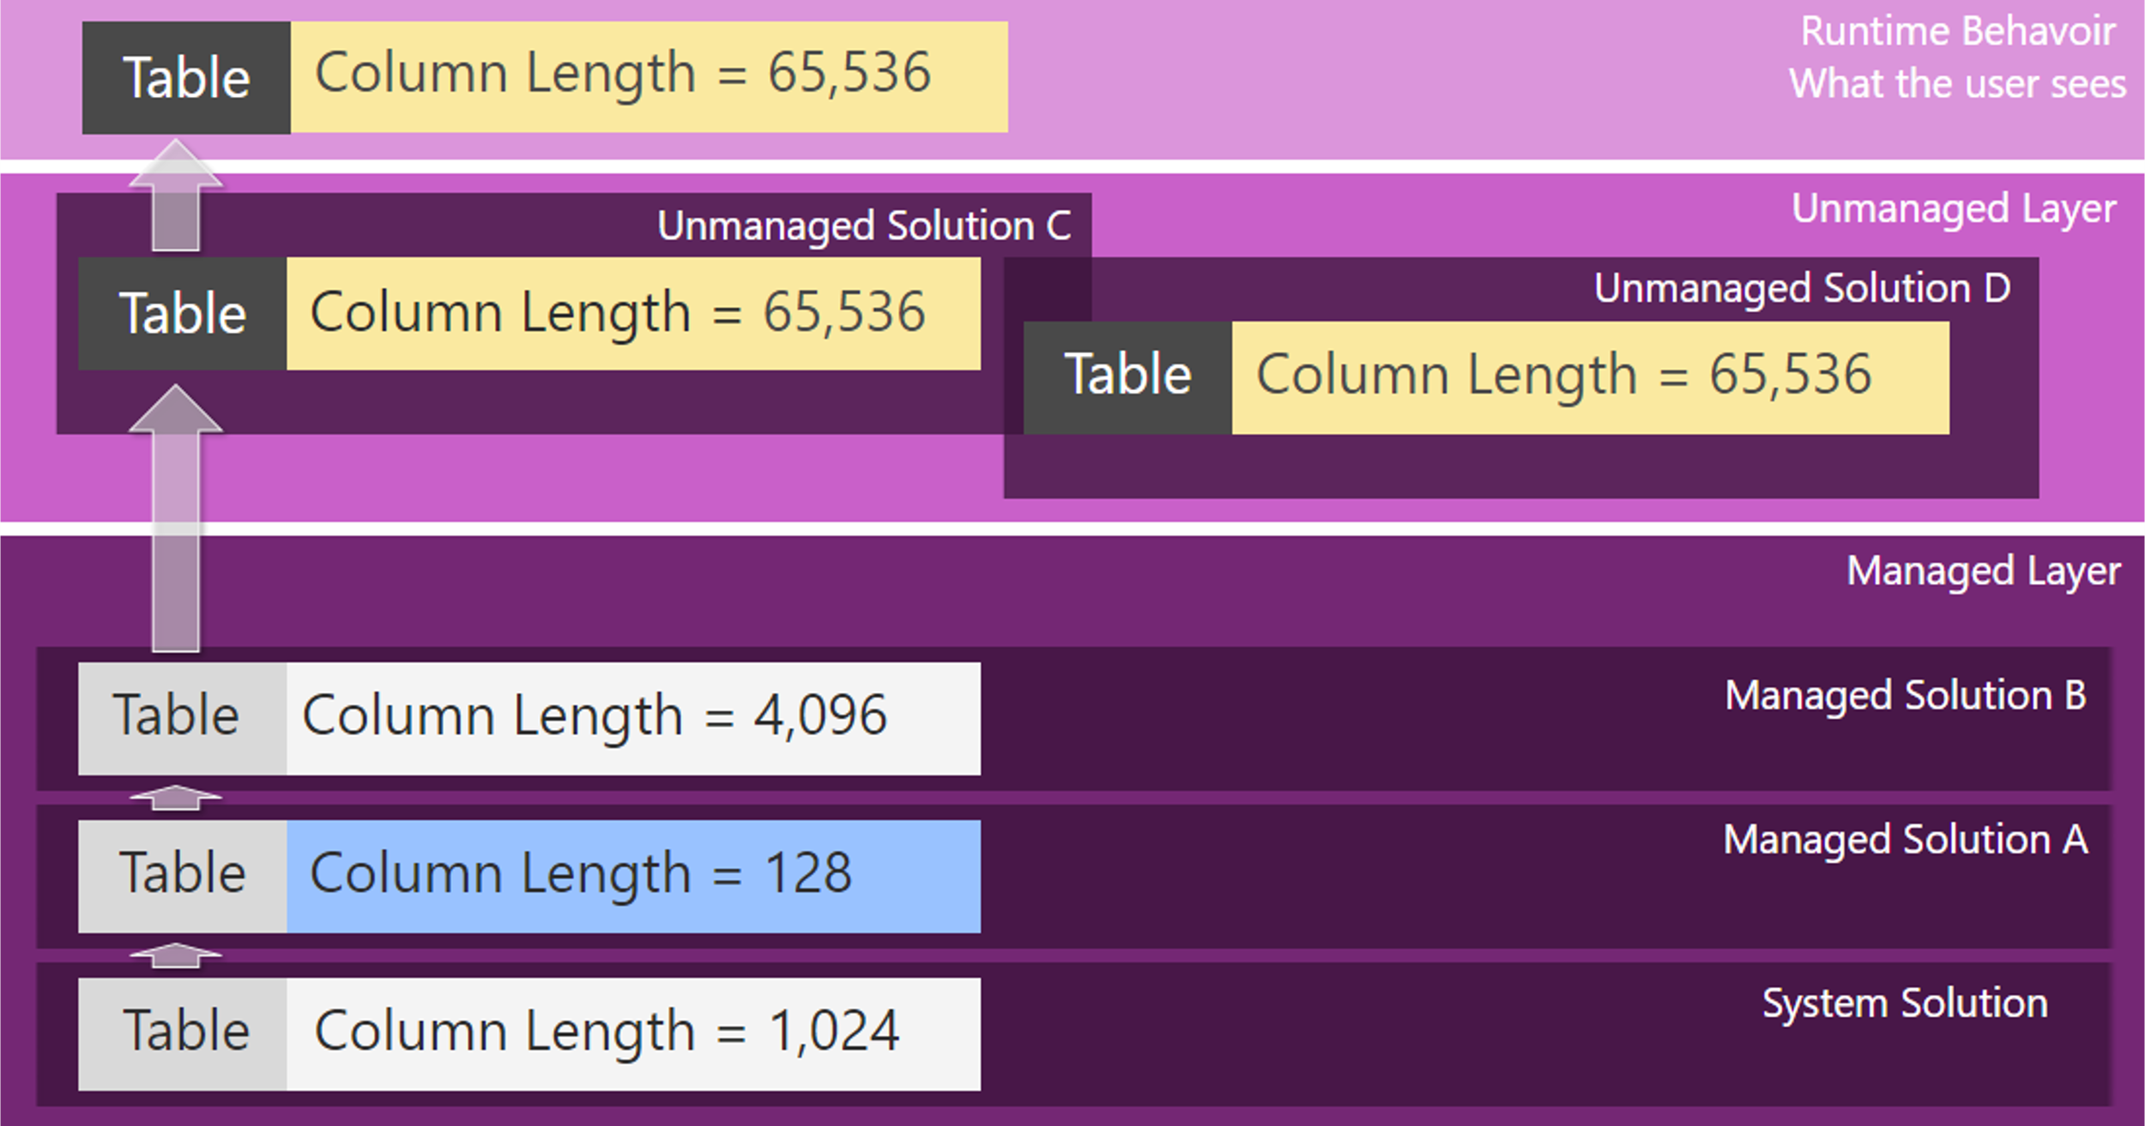
- Figure 3 - Top Wins Data model example
The layering strategy exists to establish the rules by which a power platform environment can be instantiated and managed to achieve conflict avoidance and cross solution dependencies its intent is to provide the following abilities:
- The ability to instantiate or upgrade Dataverse and MS Apps in an environment without breaking ISV or Knight Frank Solutions.
- The ability to allow installation and upgrading of ISV solutions without breaking of Knight Frank Solutions.
- The ability for Knight Frank solutions to be installed and upgraded independently of previously deployed solutions.

Prescribed pattern for Solution Layers:
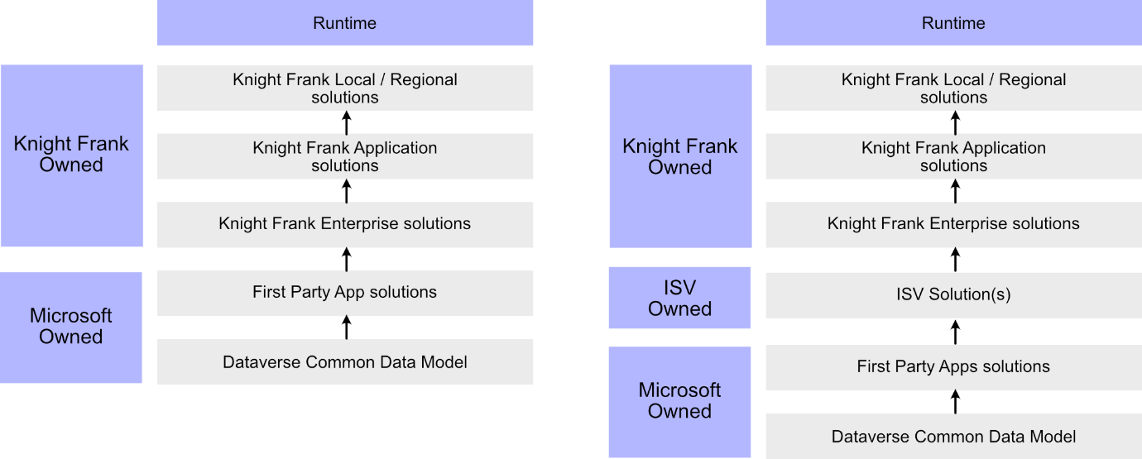
Figure 4 - Knight Frank Solution Layering (with and without ISV)

Common Data Model - System Layer
The system layer always forms the base of the pattern and comprises of the Dataverse System tables. The System Layer must not be directly customised or changed.

First Party Apps Layer (Dynamics 365 / Power platform accelerators)
First party apps are solutions built and provided by Microsoft. They must be treated as immutable as with any other ISV solution.
Examples of first party apps / solutions are the ‘Centre of Excellence Starter Kit’, the ‘Creator Kit’ and the ‘ALM accelerator’.
Dynamics 365 applications are also first party solutions and installed as the next solution layer. Contiguous layering of Microsoft application layers (e.g. Dataverse, CoE accelerators & Dynamics) ensures an immutable foundation upon which other layers can safely stack without conflict.

ISV Solution(s) Layer
The ISV solutions layer represents immutable managed solutions deployed into the environment.
They should always follow the Microsoft owned layers and must not have their objects modified by any party that is not the publishing ISV.

Enterprise Solution Layer (Core Solutions)
The enterprise layer is an implementation of the Knight Frank data governance and power platform best practices. The layer is not a fixed asset or single solution, instead it is provided as a set of defined contracts, patterns, blueprints, and granular solution packages that can be used to support application specific solutions that are used organisation wide.
The aspects of the EDM Layer are
- Key Entity Schemas and contracts designed to ensure the use of ubiquitous language and data normalisation of enterprise objects and records for example a unified definition of ‘country lookup objects’ to support a ‘country list’ that maintains UUIDs across environments.
- Security Roles aligned to the group Entra ID structures enabling the management and monitoring of platform security to be implemented with alignment to the group policies and protections.
- Shared Components and Global Plugins are provided as granular solution packages allowing for iteration and maintenance while avoiding layering conflicts. E.g. The country lookup list implementation

Knight Frank App-Specific
The Application Specific solution layer is where Knight Frank Managed solutions are applied to an environment.
The intent is to provide a layer for common business applications and extensions to be applied. The layer is a point of divergence and not intended to be homogeneous with other power platform implementations on a global scale.

Regional / Localisation Layers
Regional solution layer is where Knight Frank Managed solutions used for localisation and region-specific application extensions are applied to an environment.

Storage Guidelines
To optimise storage consumption as part of the solution Knight Frank recommend the inclusion of SharePoint Storage for files and documents.
SharePoint online should be utilised for:
- Attachments: Store file attachments (e.g., PDFs, images) in SharePoint instead of Dataverse.
- Document libraries: Link records in Dynamics 365 to SharePoint folders.
- Storage offloading: Reduce database and file storage usage in Dataverse.
Beyond the use of SharePoint, Knight Frank guidelines also stipulate the following considerations should form part of the solution:
- Automated cleanup of stale objects
- Use of the Long-term data retention options.
- Automated cleanup of logs and audit trails.
- Automated clean up of Files (excel imports in particular)
- Instantiation of Bulk Deletion jobs and rules.

Application and Platform monitoring Guidelines
Monitoring the Power Platform and Dynamics 365 Customer Engagement apps is essential for ensuring performance, security, compliance, and operational health. As part of a Power Platform and Dynamics 365 solution, several monitoring guidelines should be considered and implemented dependant on budget.

Capacity Monitoring
A Key aspect of monitoring an implementation of the Power Platform and Dataverse is capacity management.
Dataverse storage add-ons are expensive, and the total storage capacity is defined at the tenant level. Proactive monitoring of the Dataverse capacity consumption is required and should alert system administrators of capacity issues before a lack of capacity impacts operational efficiency.
In addition to Dataverse capacity Knight Frank recommend the monitoring of API limits to allow proactive measures to be taken if the risk of throttling is present.
The risk posture should be based upon the entitlement provided by the user licenses, and the seasonal peaks and troughs associated with the operational model.

Application Performance Monitoring
To enable the monitoring of flows, plugins, and model driven apps, it is recommended that the solution adopt the Data Export capabilities available through the power platform in combination with Azure Log analytics and Application Insights.

CoE Starter Kit
Reporting capabilities covered by the starter kit form a foundation for monitoring and should be considered mandatory for all implementations.

Microsoft Purview
If available in the tenant and within budget, Microsoft Purview monitoring can be instantiated to provide:
- Audit logs for user actions across Dynamics 365 and Power Platform.
- Data loss prevention (DLP) policy enforcement.
- Information protection and data classification.
Purview should form a key consideration as part of meeting the requirements for Data Governance and providing the ability to perform operations such as Subject Access Requests (SAR).

Azure Extensions Guidelines
The Power Platform and dynamics applications are provided as SaaS (Software as a Service) offerings, Microsoft provides a ‘near zero’ RPO and RTO using distributed replicas and business continuity strategies (automatic failover).
The Power Platform and Dynamics customer engagement applications fall under the Knight Frank Gold SLA Classification.
When a vendor or implementation partner develops an extension to the core platform that leverages Azure resources, these resources Must align to the wider platform SLA (budget allowing).
Please reference the appendix for the current SLA classifications.

Appendix

ALM Checklist
Task
Set up your ALM strategy at the start of your project. Align your ALM strategy with your environments, source control, implementation methodology, and automation strategy.
Make sure your ALM strategy is efficient, reliable, robust, and automated. Your ALM strategy should let you deploy your configurations and customizations smoothly across different environments, including any peripheral solution components.
Use a source control-centric approach for your ALM strategy. Source control helps you create new environments with the latest configurations without having to replicate existing environments.
Use build automation and a CI/CD pipeline for your project. Build automation and a continuous integration and continuous delivery (CI/CD) pipeline help you streamline your development and deployment processes.
Consider your implementation team's structure. Your team structure should allow for effective collaboration and give developers exclusive control where needed.
Follow best practices for ALM and for each app. Download the white paper Solution Lifecycle Management: Dynamics 365 to learn more about ALM best practices and recommendations for each Dynamics 365 app.

Knight Frank SLA classifications

Gold
The loss of the service would have an immediate impact on our ability to deliver services to our client, materially affecting our revenue or reputation, or would result in our business being non-compliant with its regulatory obligations or would introduce a significant risk to the safety of our employees. The data held within the service is critical to the operation of our business; loss of data in the event of an outage would materially impact our business (immediate or long term).

Silver
The loss of the service would impede our ability to deliver services to our clients, but a workaround is available that would manage the impact on our revenue or reputation in the immediate term. The loss of service would not put our firm in breach of its regulatory obligations and would not introduce a risk to the safety of our employees. The data held within the service is important to the operation of our business; loss of data in the event of an outage would be inconvenient but would not cause material or long-term impact.

Bronze
There is no direct dependency on this service to our ability to deliver services to our clients. The firm could tolerate an extended period of unavailability or there are alternative sources of the services provided through existing supplier relationships. The data held within the solution is low risk; loss of data in the event of an outage could be tolerated or recovered/rebuilt from alternative sources.
Service Category | Availability Target | Recovery Point Objective | Recovery Time Objective
Gold | 99.85% | < 15 seconds | <1 hour
Silver | 99.45% | 1 hour | <4 hours
Bronze | 98% | 24 hours | <8 hours*

*Note: It is acknowledged that the ability to meet the recovery targets in a major disaster recovery scenario, which requires the recovery of multiple services, will be constrained by logical and physical limitations of the recovery technologies (e.g. IOPS and network capacity) and the availability of skilled resource with the knowledge to competently perform the recovery process.

